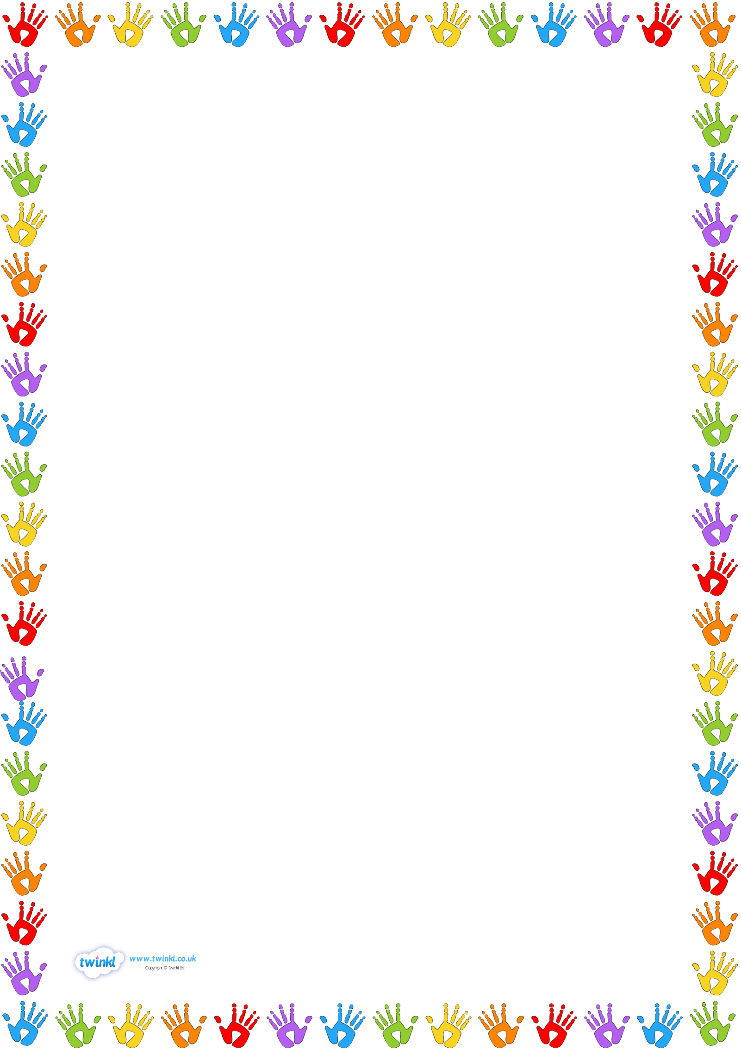

**Go Potty**

**Pottery Painting Classes**

Go Potty is thrilled to be able to offer one off pottery painting classes at St. Benedicts.

Children love to be creative and what better way than to paint their very own pottery. Each piece will be glazed and fired to create a glossy individual masterpiece your child can treasure.

There will just be one class per half term, concentrating on a different theme depending on the time of year ie Halloween, Xmas, Valentines, Mother’s Day, Easter, Father’s Day.

**This weeks class will be for Fathers Day. The class will be on Wednesday 5th Junel, 3.30 – 4.30. The class will be available for all students in reception through to yr6.**

All pottery will be delivered back to the children at school the following week.

The price is £8.50 per class. Parents can book by going on the following link. <https://bookwhen.com/gopotty> . Please ensure you click on the correct school. Places are limited and are on a 1st come 1st served basis.

Payment can be made by:

* Bank transfer, please contact me for details.
* cash or cheque (made payable to Shauna Almond). Please ensure payment is in a sealed envelope with your child’s name on the front. It can be left at the school office.

Dates for further classes will be sent out at the start of each half term.

**Mobile: 07870 825080**

**Email: gopotty@outlook.com**

