If you have any questions, please feel free to contact us on 01625 520207.

We hope you have enjoyed looking at pictures of your new school. We look forward to seeing you in September!

Welcome to

**St Benedict's**

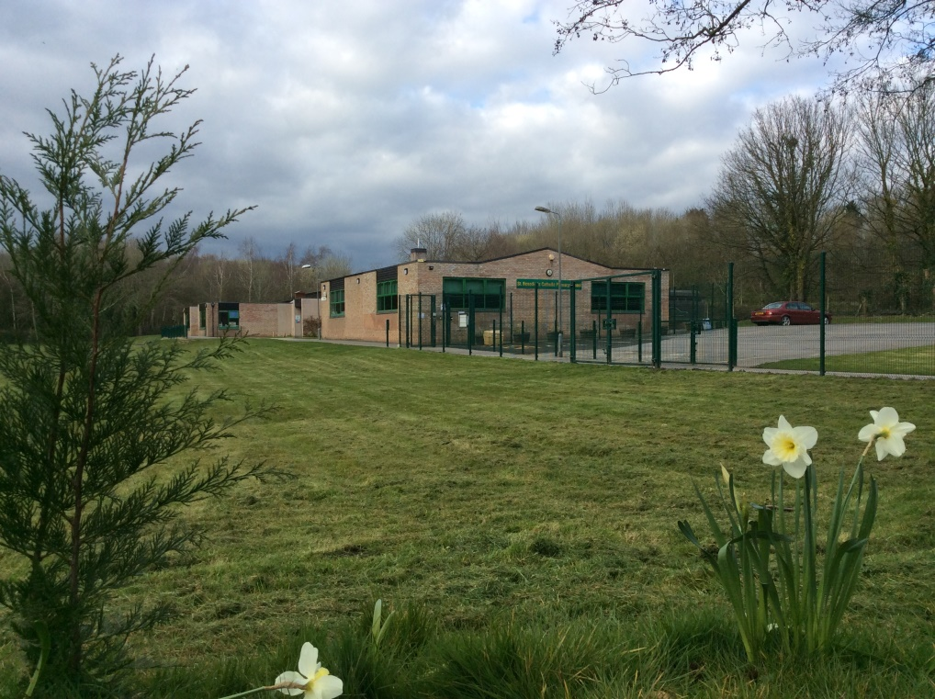



Hello and welcome to St Benedict’s. We are so excited for you to start school with us in September.

This is your class teacher – Miss Ogden



**Here are some more people you will meet:**

This is Mrs McGuire, our head teacher.



This is Mrs Bahsoon, who works in the school office.

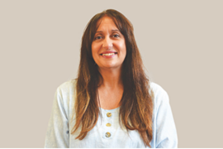

This is your teaching assistant,

Mrs Everett.

This is our school cook Ashley 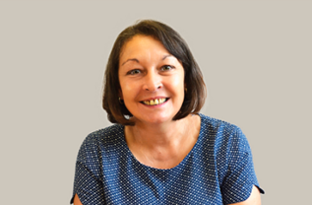

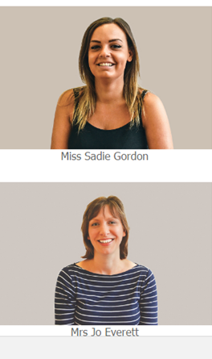

**We can’t wait to meet you!**

You have a special playground. Outside you will be able to learn with your friends in the sand and water area, and have fun with the bikes and lots more exciting things.

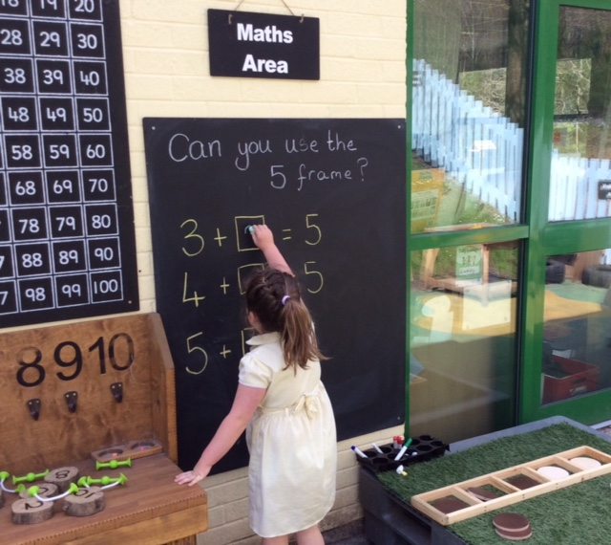 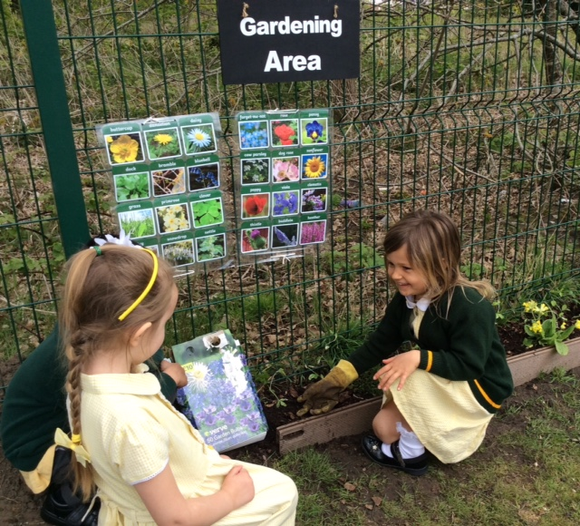

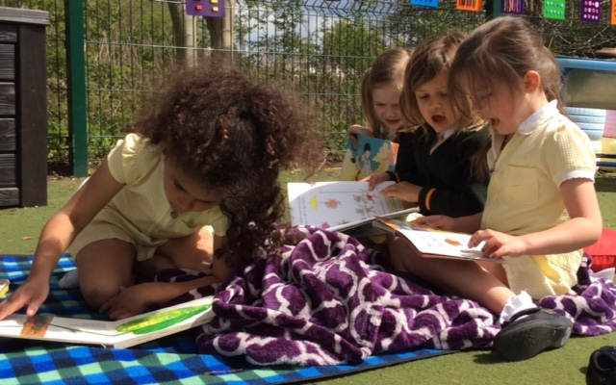 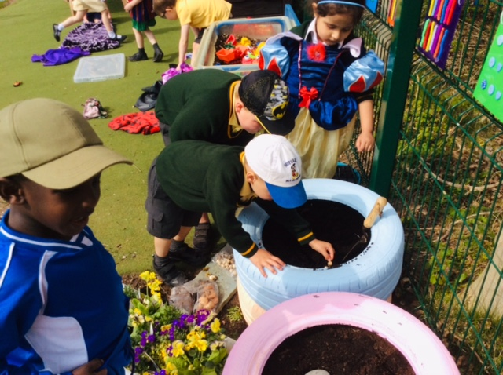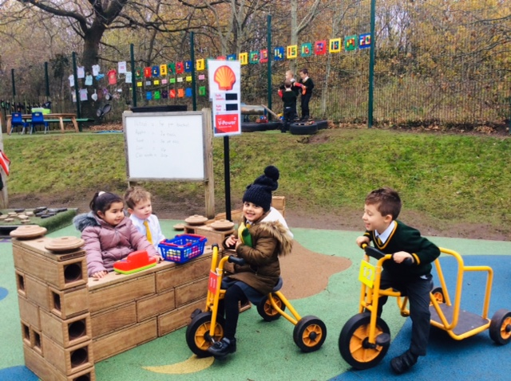 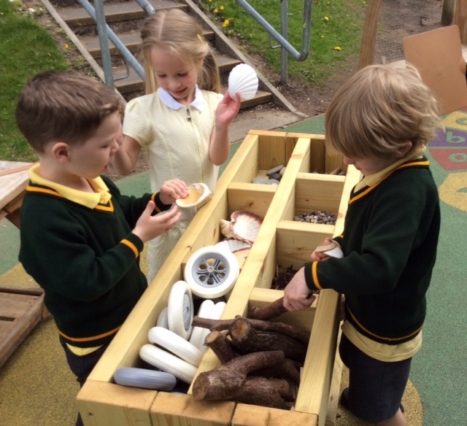

This is the cloakroom where you will hang up your coat and PE bag. We also have a wellie rack, so bring your wellies too.

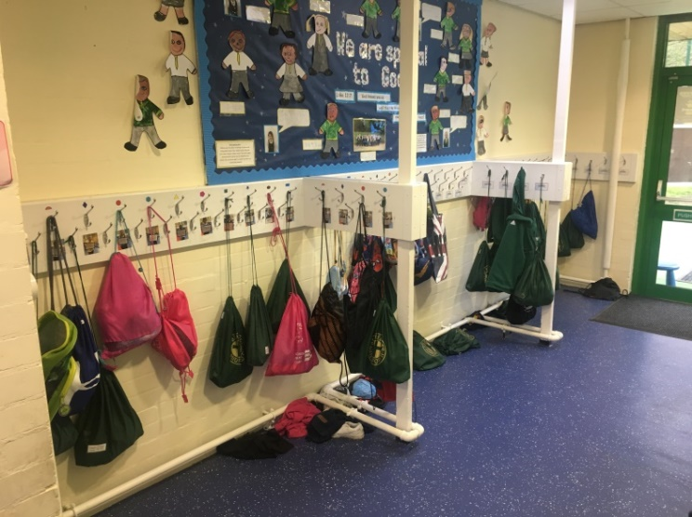

This is where you will put your book-bag and, if you decide to bring a packed lunch, you can put it here.

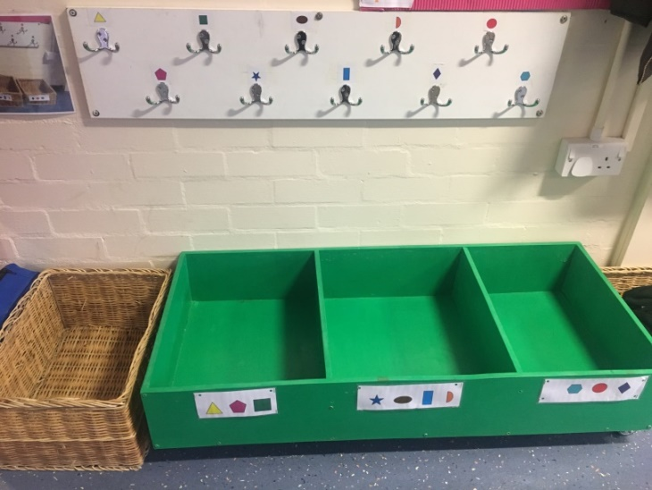

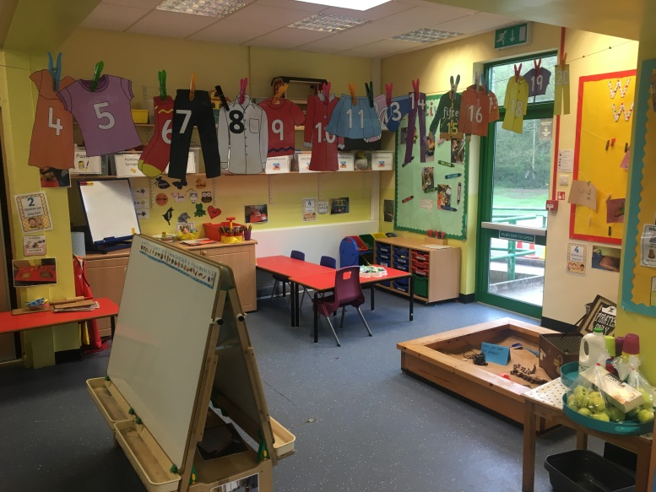

This is the school hall where you will come to have your dinner, and for assemblies.

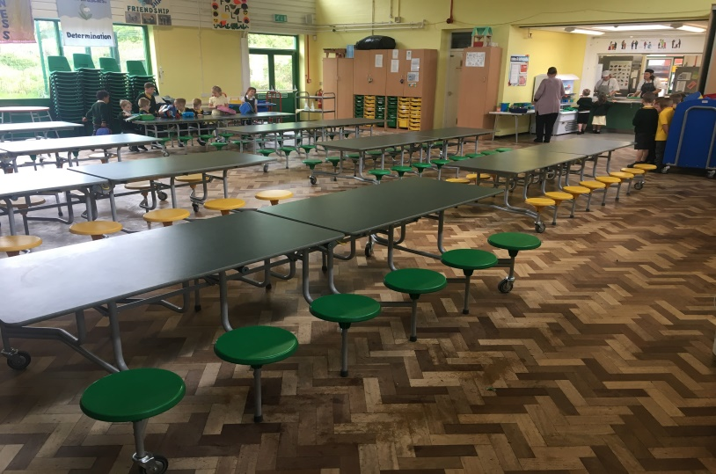

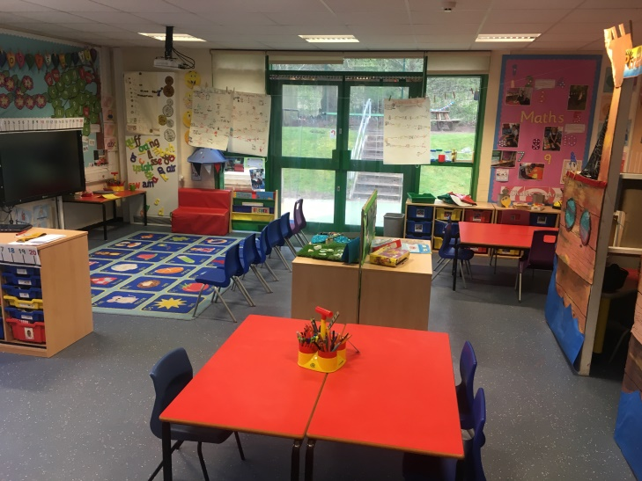

Sometimes we have a celebration assembly when all the Mummies and Daddies can come too.

This is our classroom, where we have lots of fun things planned for you.