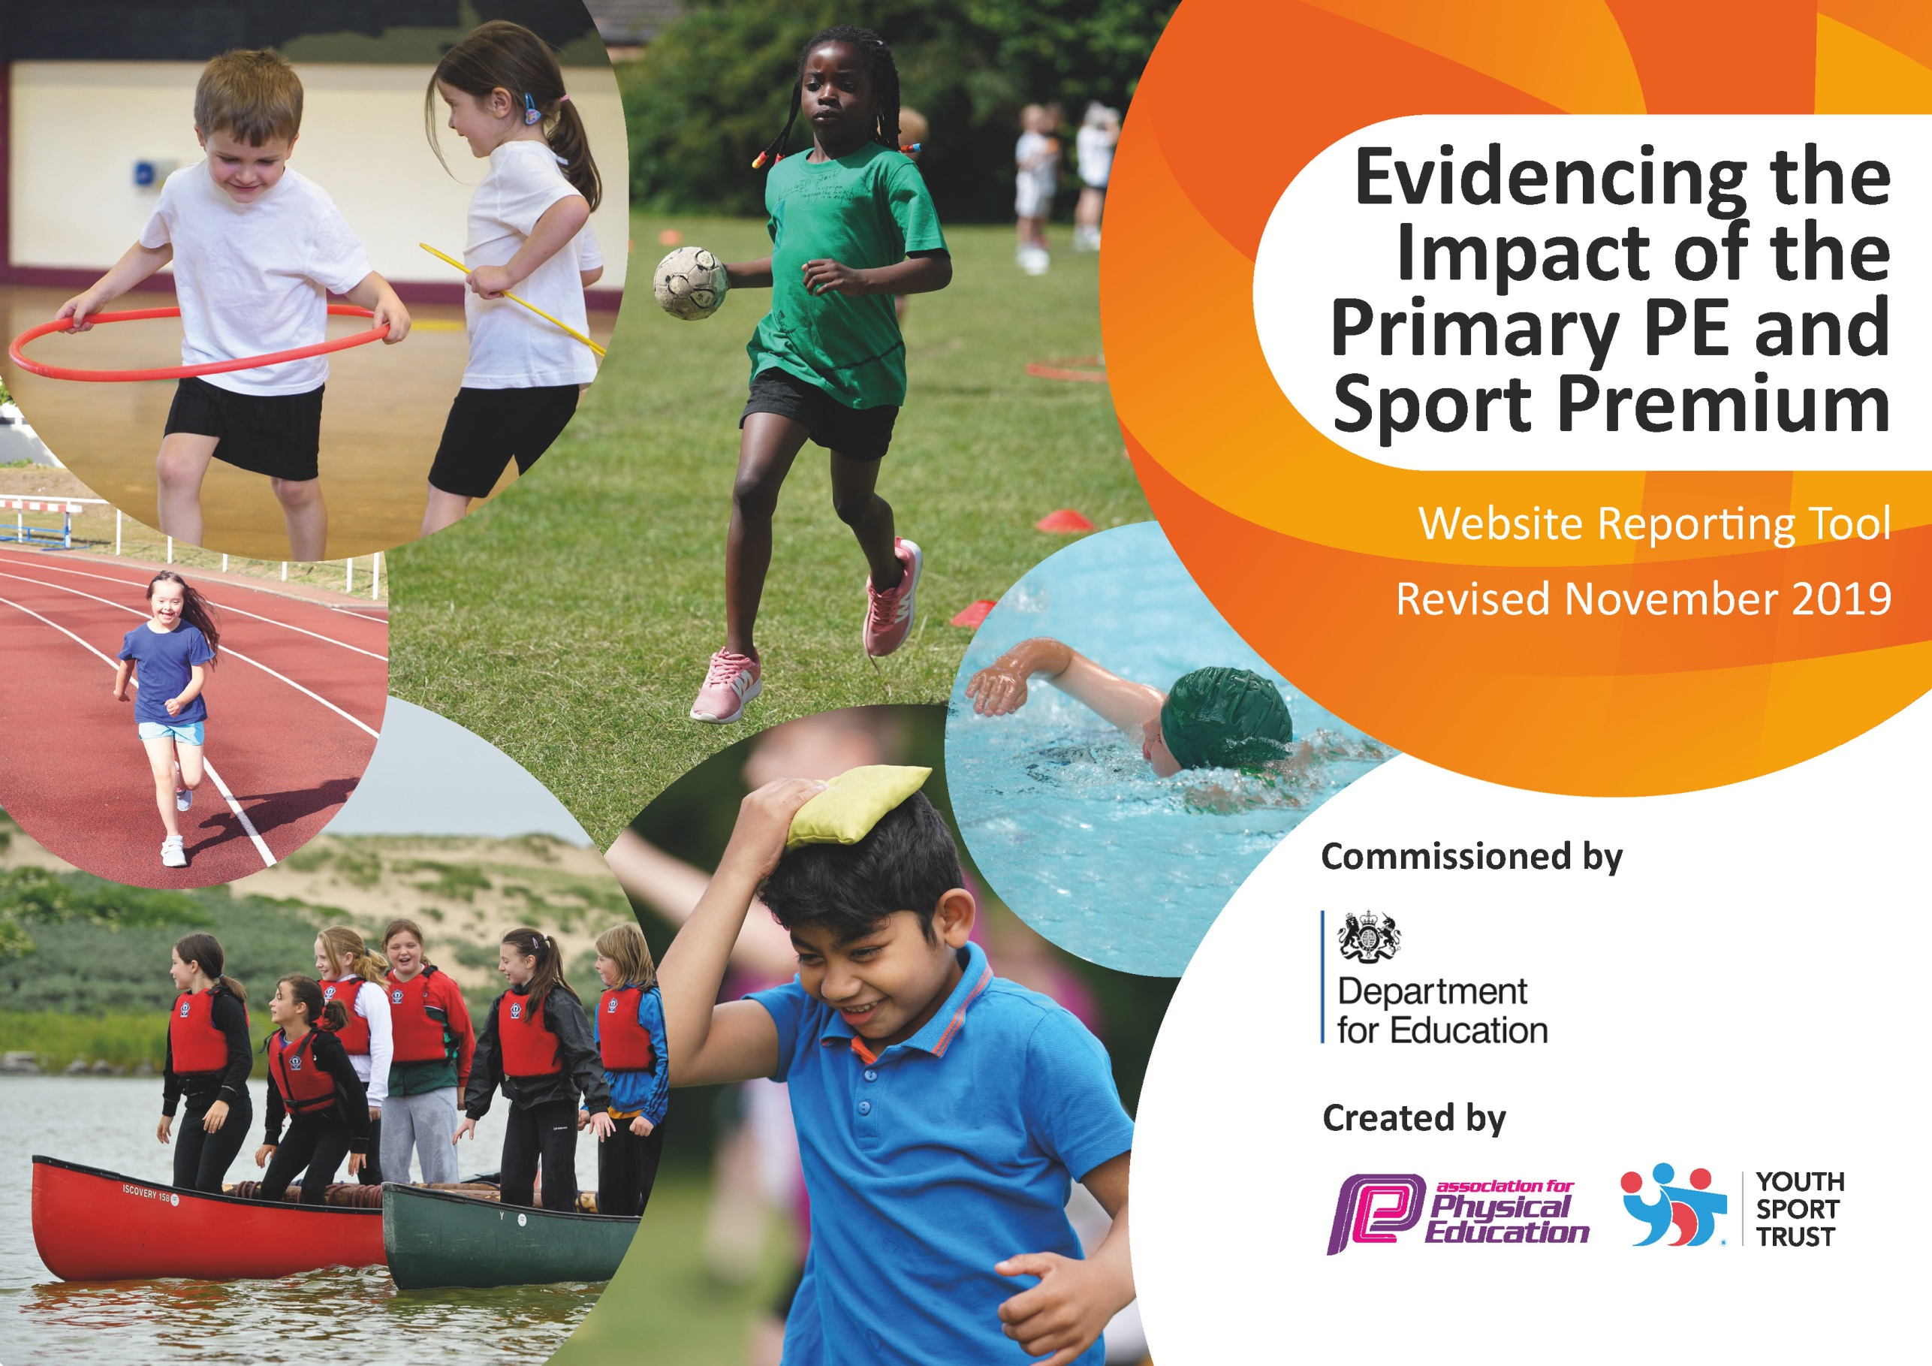
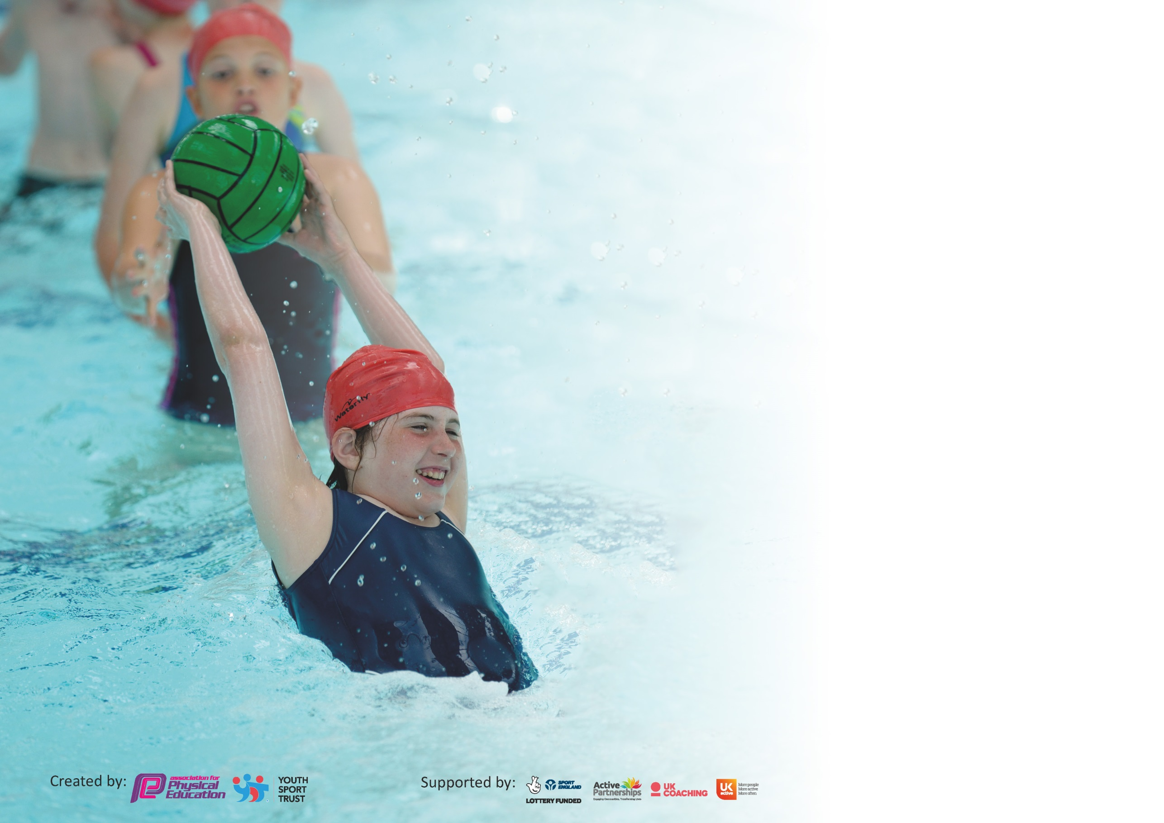

It is important that your grant is used effectively and based on school need. The Education Inspection Framework (Ofsted 2019 p64) makes clear there will be a focus on ‘whether leaders and those responsible for governors all understand their respective roles and perform these in a way that enhances the effectiveness of the school’.

Under the Quality of Education criteria (p41) inspectors consider the extent to which schools can articulate their curriculum (INTENT), construct their curriculum (IMPLEMENTATION) and demonstrate the outcomes which result (IMPACT).

To assist schools with common transferable language this template has been developed to utilise the same three headings which should make your plans easily transferable between working documents.

Schools must use the funding to make additional and sustainable improvements to the quality of Physical Education, School Sport and Physical Activity (PESSPA) they offer. This means that you should
use the Primary PE and Sport Premium to:

- Develop or add to the PESSPA activities that your school already offer
- Build capacity and capability within the school to ensure that improvements made now will benefit pupils joining the school in future years

Please visit gov.uk for the revised DfE guidance including the 5 key indicators across which schools should demonstrate an improvement. This document will help you to review your provision and to report your spend. DfE encourages schools to use this template as an effective way of meeting the reporting requirements of the Primary PE and Sport Premium.

We recommend you start by reflecting on the impact of current provision and reviewing the previous spend.

Schools are required to publish details of how they spend this funding as well as on the impact it has on pupils’ PE and sport participation and attainment by the end of the summer term or by 31st July 2020 at the latest.

We recommend regularly updating the table and publishing it on your website throughout the year. This evidences your ongoing self-evaluation of how you are using the funding to secure maximum, sustainable impact. Final copy must be posted on your website by the end of the academic year and no later than the 31st July 2020. To see an example of how to complete the table please click HERE.

Support for review and reflection - considering the 5 key indicators from DfE, what development needs are a priority for your setting and your pupils now and why? Use the space below to reflect on previous spend and key achievements and areas for development.

Key achievements to date until July 2020: | Areas for further improvement and baseline evidence of need:
Children are exposed to a range of activities/sports  Achieved the Platinum Sports Mark  Gymnastics specialist employed to coach staff  Staff receive regular sport CPD from external specialists  SEND pupils access yoga once a week with an ASD Yoga specialist and a gross motor skills session once a week with a specialist sports coach  PE curriculum has been developed and personalised for our school to ensure teachers deliver high quality PE lessons | Extend the sports available to pupils to include non-traditional sports and particularly to include disadvantaged pupils  Provide after school sports clubs for disadvantaged pupils – rugby football yoga gymnastics  Upskill TAs in supporting the less able pupils during a whole class session  Catered for and involve every group within competitions:  Less-Active children, SEND children, BAME children, EAL children, More able  Enhance children’s understanding of healthy eating and encourage them to be more active  Enhance challenge within the curriculum and support those who are gifted in sport  Midday supervisor training to encourage active play  update the equipment for the After School club  Research more permanent structures for the playground (daily mile track etc)  Purchase new equipment for Early Years

Meeting national curriculum requirements for swimming and water safety.
What percentage of your current Year 6 cohort swim competently, confidently and proficiently over a distance of at least 25 metres?  N.B. Even though your pupils may swim in another year please report on their attainment on leaving  primary school at the end of the summer term 2020. | Unable to assess due to COVID
What percentage of your current Year 6 cohort use a range of strokes effectively [for example, front crawl, backstroke and breaststroke]? | Unable to assess due to COVID
What percentage of your current Year 6 cohort perform safe self-rescue in different water-based situations? | Unable to assess due to COVID
Schools can choose to use the Primary PE and Sport Premium to provide additional provision for swimming but this must be for activity over and above the national curriculum requirements. Have you used it in this way? | Yes/No due to COVID – would have done so.

Action Plan and Budget Tracking
Capture your intended annual spend against the 5 key indicators. Clarify the success criteria and evidence of impact that you intend to measure to evaluate for pupils today and for the future.

Academic Year: 2020/21 | Total fund allocated: £17675 Spent: 18563 | Date Updated: September 2021
Key indicator 1: The engagement of all pupils in regular physical activity – Chief Medical Officer guidelines recommend that primary school pupils un/dertake at least 30 minutes of physical activity a day in school
Intent | Implementation |  | Impact | Sustainability and suggested next steps:
Children use yoga to improve flexibility, posture and concentration in lessons by practicing in class and applying themselves | Specialist session for SEND pupils each week  Morning session with a specialist for 2 groups of children | Funding allocated:  £ 375  £ 500  £30 | Children apply simple yoga moves in the classroom at the beginning of lessons and when they feel the need to and learn a skill | To reintroduce the yoga club after school
UKS2 sports ambassadors lead the ‘Change for Life’ programme with other pupils and encourage regular participation | The Sports coach works 5 days a week at lunchtime supporting pupils to set up games for other pupils and encouraging all pupils to exercise regularly. | £ 10000 | All children take part in regular activity. The Sports’ Coach worked with classes each lunchtime to ensure that they had regular exercise. Children now confident and able to run their own sessions with minimum adult support. | Train new cohort of ambassadors 2021/22  Ensure that they are confident to run their own sessions.
Children experience and enjoy a variety of sports after school. | Children have access to a range of sports after school from external providers – girls’ football, tag-rugby, yoga, gymnastics, tennis, netball. | £256 | Children have gone on to participate outside of school – girls’ football encouraged girls to play in teams outside of school – Macclesfield Ladies.  7 children who do not normal attend have now attended after school sessions and are engaging in sport during and after school. | Identify more pupils who are not engaging in activities themselves and pay for their after school subscriptions.  Organise an in-school group with an external coach
Children have access to well-maintained and high quality PE equipment | Purchase of new equipment for use at lunch including: netball nets, | £450 | Children have plenty to do during breaks to encourage activity and participation in sports. | Maintain and build upon equipment. Regular stock checks  Purchase Early years equipment for active play
Children to be active during playtimes in self-sustaining games | Stencils and spray paints purchased to mark playground with ‘jump, stick, twist course’, hop scotch etc. | £150 | Children are active in the playground and on the field | Invest in further stencils to encourage more movement- re-do markings
Catch- up swimming lessons | Did not happen due to COVID. Pupils will attend lessons in Spring and summer terms and lessons wil be paid for for Y6 pupils who are unable to reach 25m | n.a | Children will all be able to swim when they leave primary school | Need to assess all pupils including Y6 pupils and provide lessons for them if they cannot swim 25m
Key indicator 2: The profile of PE and Sport being raised across the school as a tool for whole school improvement
Intent | Implementation |  | Impact
Children understand why healthy snacks are so important and how to eat healthily | Healthy week organised for June 2020 to focus on healthy eating and healthy snack choices to coincide with an Olympic athlete visit. | Costs not attributed yet due to COVID.  TBC circa £500 for costs. | TBC: Hoped impact – children to make healthier choices and school to move toward healthier snack choices. | Event rearranged for Harvest Festival week to focus on vegetables and interesting ways to eat them
All children are active and ride/walk or scoot to get to and from school | Bike ability sessions for older children.  Encourage, through the house system, children to walk/ride/scoot to school. | Certificates  Tokens  Badges  £150 | Children participate in bike ability in years 4 and 6. | Consider children who do not have access to a bike and consider hiring a bike for them to participate  Monitor methods of travelling to and from school and encourage more activity
Children are exposed to key vocabulary | Key words on field, in hall and on playground to encourage children to read, understand and think about key words | £200 for signs | Children will think about and integrate key vocabulary into their daily life.
Premier League Primary Stars Teacher CPD | CPD for teachers – Practical delivery upskilling teachers with different methods/tools for engaging pupils in physical activity | N.A
Premier League Primary Stars maths/literacy attack | fun, engaging games and activities in maths and reading to engage pupils in KS2 | N.A | Hard to reach pupils will be engaged in sporting activities and will foster a love of reading/Maths | Reintroduce after COVID restrictions lift to mix groups

Key indicator 3: Increased confidence, knowledge and skills of all staff in teaching PE and sport
Intent | Implementation |  | Impact
Teachers feel confident in teaching high quality PE lessons which cater for all abilities. | Sports coach – employed to provide CPD and upskill teachers in the delivery of PE. Teachers take part in sessions with sports Coach leading and upskilling. | Funding allocated:  £4025 | PE lessons are of a better standard and each pupil receives 2 hours of good quality PE one led by the coach and one by the teacher.  Teachers will no longer need to be supported by the Sports coach | Sustainability and suggested next steps:  Sports coach will not be used in curriculum time. Coach will run lunch activities, 4 sessions
Specialist activities will be run by external coaches to upskill staff. | Flamenco, ballet, gymnastic specialists will lead a unit of work as CPD for the staff | £245  £495 | Teachers will be more confident when leading sessions in dance and specialised areas and children will have a high quality education in these areas. Children will be have exposure to different activities and will take up the interest outside school.
Key indicator 4: Broader experience of a range of sports and activities offered to all pupils
Intent | Implementation |  | Impact
Children experience a wide range of activities in addition to the sport offered in PE and as after school clubs | Golf taster day  Cricket After school sessions  Athlete visit and circuit  Flamenco sessions  Martial arts  Dodgeball | Visiting specialists  Golf £60  Athlete will be £450 (delayed due to Covid) |  | To research other local options: fencing, horse riding, martial arts, water sports
 | Residential trip to Robinwood in Years 3,4 and 5 enable children to experience archery, kayaking, rock climbing, caving etc | Disadvantaged pupils subsidised for trip to Robinwood with PP funding  TA costs offset for accompanying groups  £ 280  Teacher cost for additional day salary:  £250 | Children have a great experience and really enjoy a wide range of new activities.
Pay for supply staff to cover PE lead to enable attendance at sporting activities |  | £ Not spent due to COVID restrictions on activities

Key indicator 5: Increased participation in competitive sport
Intent | Implementation |  | Impact
All year groups engage in sporting activity in a competitive manner | Part of the All Hallows and Wilmslow High cluster of schools inter school competition network Children of all age groups participate in competition – gymnastics, football, Cross-country, tag-rugby, boccia etc – against other schools.  Sports coach trained the football team after school and took them to competitions. | £8 per child cost paid to AHLC community. Costs for transport  TA support &  Sports Coach  £ 1600 | Children experience competing against other peers and representing a team  School performed better in the competitions and won the football league and netball league 2019 | Sports coach to work with children after school in clubs particularly the disadvantaged pupils who do not engage in sport out of school – to encourage fitness and develop skills to increase confidence in competition. Survey pupils in September.
Children to participate in intra school competitive events. | Whole school sports day run by external provider to include all ability levels and a range of activities. Prior to sports day, external provider sessions at lunch to improve skills in key areas – javelin, long jump etc. | Costs of medals and certificates  TA costs for sports day  £237 | All children participated in 2020 sports day and will show improvement in athletics
Children will be prepared and trained to participate in | Sports’ coach will work with a team prior to an event to prepare them. | Didn’t happen because of COVID | All children will have chance to excel and achieve

Signed off by
Head Teacher: | Hannah McGuire September 2021
Subject Leader: | Thomas Acton
Date: | 6th September 2021
Governor: | FGB September 2021

